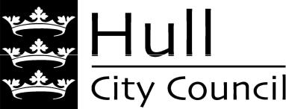


Boulevard and St Andrew’s Quay Pride in Place Programme needs an Independent Chair to spearhead community action - could this be you?

What is the Pride in Place programme?

The Pride in Place programme is a new government funding programme, aiming to put power into the hands of local people in some of the most in-need neighbourhoods in the UK, so that they can decide how to regenerate their local area. It gives communities control of £20m over the next 10 years, to be spent on projects that will make a real difference to the neighbourhoods they live in. The programme is:
- Long-term: providing certainty and security of funding over 10 years.
- Flexible: allowing communities to spend their funding on the projects that matter most to them, in a way that works for them.
- Community-led: putting local people at the heart of decision-making, with residents having their say on the future of their neighbourhood.
- Supportive: empowering people to build the skills and confidence they need to deliver change in their communities

The Pride in Place neighbourhood programme is aimed at regenerating the most in need neighbourhoods focussing on geographies of around 10,000 residents. The guiding principle is that the long-term funding is intended to support communities in shaping their place, and prioritising funding, based on extensive community engagement around three core goals:
- Building stronger communities
- Creating thriving places
- Empowering people to take back control

In Hull, three areas have been selected for inclusion in the programme and will each receive £2 million each year over the next 10 years. The map below shows the Boulevard and St Andrew’s Quay area that has been awarded funding.

Boulevard and St Andrew’s Quay

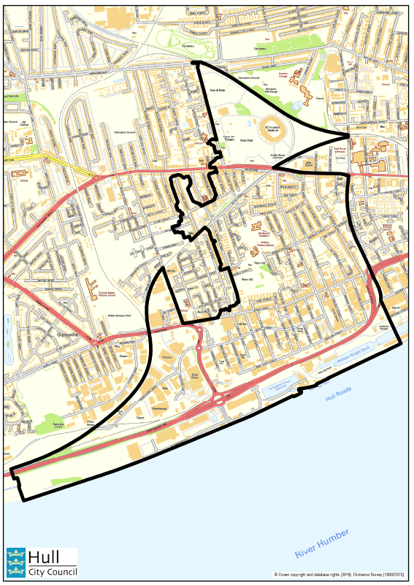

Why are Independent Chairs leading the Pride in Place Neighbourhood Boards?

To deliver the Pride in Place Programme, Pride in Place Neighbourhood Boards are being set up. Each Board will be led by an independent Chair – someone who can bring communities together to share their ideas in an open and collaborative way. The Chair’s primary job is to be a champion for their place and to embody the community-led spirit of the programme. The Chair must live in the area, hold a prominent role in the community, and have a passion for the area that has been awarded the funding. The Chair can be new to this kind of work. What matters most is a commitment to seeing change through and improving the lives of those in their community. Boards will have to submit a plan to government about how they propose to use the funding, and the Chair role is key to ensuring that this genuinely reflects the needs of the community.
The Independent Chair will act as a proactive, trustworthy convenor who:
- Is deeply connected to their community and fiercely committed to making it an even better place to live.
- Can bring together different voices from across their community, to shape a collective vision for the future of their place.
- Has local credibility and will be respected as a leader – even if this is their first leadership role.
- Ensures that all voices are heard and that Board discussions are collaborative.
- Is adept at finding consensus, navigating conflict calmly and impartially, never allowing ego to get in the way of progress.
- Brings together community groups and prioritises community engagement as a central pillar of the programme.
- Is clear about their own knowledge gaps and considers how the makeup of the Board complements this.
- Thinks laterally and creatively about solutions to problems and ways to draw in community voices.
- Acts as a public face and represents the Board externally, and brings figures of different political stripes together.
The Chair should not be:
- A gatekeeper or clique-builder; the Board should have a range of voices, including ones that differ from the Chair’s.
- Seeking to push personal agendas – this is about what the community wants.
- The only decision-maker or expert in the room.
- The day-to-day delivery lead: this is a strategic role.
- An elected representative (local councillor or MP)

What skills, knowledge or experience is required for the role?
Skills and attributes of a good Chair:
- Fair and balanced, ensuring that all voices are heard
- Good at facilitating conversations, particularly when differences of opinion emerge
- Open to learning, feedback and development, and an interest in mentoring and upskilling others
- Welcoming, open and listens deeply to others
- Calm under pressure and manages conflict well
- Has time to prioritise the role
What support will the Chair receive to carry out their role?
The Chair of the Neighbourhood Board will receive ongoing support from both Hull City Council as the Accountable Body for the funding, and also the local MP. The Chair will be supported in the process of recruitment of local stakeholders and residents to their Boards, and throughout the process of developing strategic priorities for each area. Secretariat and governance support for the Board will also be provided.
In most circumstances we expect this role to be voluntary, similar to that of a school governor or charity trustee. However, to ensure that Neighbourhood Boards have the right leadership, and to open the position up to candidates who might otherwise be unable to put themselves forward, a small basic payment may be provided from the programme’s dedicated capacity funding to remunerate Chair time.
What is the time commitment?
The Chair will be required to attend a number of Board meetings a year plus occasional development or engagement sessions. Some reading of board papers will be required before each meeting, also liaison with Hull City Council regarding programme management processes. In the early stages of the programme the Chair will also need to commit time to liaise with the local MP and Hull City Council to support the establishment of the Board and development of a local Pride in Place plan.

What will the Pride in Place Neighbourhood Boards look like?
The Board will bring together residents, local businesses, grassroots campaigners, workplace representatives, faith, and community leaders and those with a deep connection to their area. The local authority and the local MP must approve the final Board selection, which will include local residents. Neighbourhood Boards must also include the relevant local MP and at least one ward councillor. They should be resident-led, to ensure that they are representative of the communities that they serve. The Boards must ensure there are more residents and people who live or work in the area on the Board than there are elected representatives.
To encourage diverse and inclusive Boards, the chair will want to consider membership from the following groups:
- Community leaders, organisers and activists, such as local charities, faith groups, community groups, neighbourhood forums, youth groups or social clubs
- Local businesses and social enterprises, such as key local employers, the local Chamber of Commerce or Business Improvement District, registered social housing providers or Co-operatives
- Cultural, arts, heritage and sporting organisations, such as local sports clubs or sporting organisations, local heritage groups or local museums and arts spaces
- Public agencies and anchor institutions, such as local schools, higher education and further education institutions, local health care providers, or relevant representatives from local authorities
This list is non-exhaustive, and membership will depend on the local context.
Where can I find out more about the Pride in Place Programme?

More details and background information can be found either on the Council’s website: Pride in Place Programme | Hull or on the Government’s website: Pride in Place Programme prospectus - GOV.UK

How do I apply for the role?
If you think that this role might be for you, please complete the expression of interest form and return it to prideinplace@hullcc.gov.uk or by post to be received no later than noon on 19 February 2026.

The expression of interest form is available electronically on the following webpages Pride in Place Programme | Hull.

If you would like an informal discussion about the role please contact your local Ward Councillor, Member of Parliament, or email prideinplace@hullcc.gov.uk.

Applicants for the role will be contacted by the 3 March to inform them if they have been selected for interview.

Interviews will be held between the 6 March and 10 March 2026.

Confidentiality

The information you supply in your expression of interest form will only be used to help with the shortlisting and selection process for the Pride in Place Programme.

By completing and submitting an expression of interest form, you consent to Hull City Council processing such personal data as may be necessary for the administration of the selection processes or meeting our obligations with the grant funding associated with the Pride in Place programme.

The information you supply will not be used in any other way and will be processed in accordance with your rights under the Data Protection Act 2018.

