HERITAGE STATEMENT TEMPLATE
Conservation Areas
March 2026

INSERT NAME OF BUILDNG/SITE
INSERT DATE
INSERT NAME OF AUTHOR

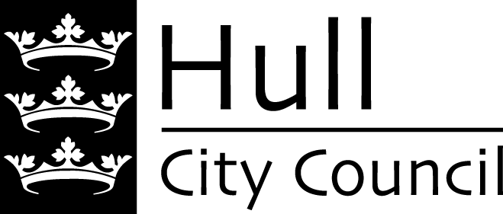

Conservation Areas
This statement should be completed if your development is located within a Conservation Area or within the setting of a Conservation Area.
The proposed development will affect the following Conservation Area or areas:

* To find out if you are located within a conservation area please visit - https://maps.hull.gov.uk/

Heritage Statement Requirements
Heritage Statements are a local validation requirement. They are written to demonstrate how an application complies with statutory requirements, and national and local planning policy for heritage assets. When completing the sections please consider the following requirements:
National Planning Policy Framework:
Paragraph 207 - “In determining applications, local planning authorities should require an applicant to describe the significance of any heritage assets affected, including any contribution made by their setting. The level of detail should be proportionate to the assets’ importance and no more than is sufficient to understand the potential impact of the proposal on their significance. As a minimum the relevant historic environment record should have been consulted and the heritage assets assessed using appropriate expertise where necessary.” Etc.

Paragraph 213 – “Any harm to, or loss of, the significance of a designated heritage asset (from its alteration or destruction, or from development within its setting), should require clear and convincing justification.” Etc.

Legal Requirements:
Planning (Listed Buildings and Conservation Areas) Act 1990:
- Section 72(1) – “In the exercise, with respect to any buildings or other land in a conservation area, of any functions under or by virtue of any of the provisions mentioned in subsection (2), special attention shall be paid to the desirability of preserving or enhancing the character or appearance of that area.”

Hull Local Plan
To determine how the scheme determines with the following sections of the Hull Local Plan:
- Policy 14 (Design)
- Policy 15 (Local Distinctiveness)
- Policy 16 (Heritage)
- Policy 19 (Shop Fronts)
- Policy 20 (Advertisements)

A full copy of the policy requirements can be read here - https://www.hull.gov.uk/strategies-policies-plans-performance/local-plan

Affected Conservation Area (s)
My building/site is in the ‘insert’ Conservation Area (s).
To find out if your building or site is within a conservation area visit –
https://maps.hull.gov.uk/

Heritage Significance
Please identify the significance of the conservation area affected by the proposed works.

- Where there is a published Character Appraisal and Management Plan the relevant section of the document should be referenced.
- A list of published ‘CAMP’ documents is available here - https://www.hull.gov.uk/building-standards-regulations/conservation-areas/3
- If the conservation area does not have a published ‘CAMP’ please describe the special interest of the conservation area relevant to the works being proposed.

Photos
Provide photos of the area of the conservation affected by the proposed works.

Impact of Proposed Works.
Please describe the impact of the proposed works upon the ‘character and appearance’ of the conservation.
Items to consider:
- Do the materials match the local area?
- Does the development match the architectural style of the area?
- Is the type of development typical of the local area?
- Does the development positively or negatively impact upon key views?
- Does the development positively or negatively impact upon an open space?

Management Plans
Where a conservation area has a published management plan* please describe how the proposed works comply with published guidance.

*Please see - https://www.hull.gov.uk/building-standards-regulations/conservation-areas/3

Justification
Explain why are the works being proposed?
Items to consider:
- If they are not considered as being harmful.
- That they achieve a public benefit.
- Do they bring the building back into use?
- Are they addressing repair and maintenance issues?
- Has a specialist report been commissioned to explain why works are taking place?
- Can the works be undertaken without harm?
- Do they comply with local plan policies?

Heritage Impact Assessment Summary – Conservation Areas
Proposed Work | Heritage Impact | Justification

Other Information
Additional Information
Please provide any other information which you consider is relevant to the determination of your application.

