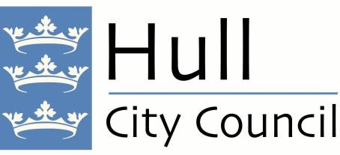

Vehicle Crossings

Customer Information

Thank you for your recent enquiry regarding constructing a vehicle crossing at your address.

This information pack contains all the information you need to obtain a quotation for a crossing from an approved contractor.

Hull City Council now allows vehicle crossings to be constructed by a number of approved contractors through the issuing of a road works permit.

General Information

- It is important to remember that once a crossing has been constructed it remains part of the highway and Hull City Council will be responsible for its maintenance, in addition parking is not permitted on the crossing once it has been constructed. Your vehicle must not overhang the footpath when you park within your property.

- Crossings are constructed in tarmac however in some instances other materials may be approved for use.

- Please note that no new H bar markings will be installed to newly constructed vehicle crossings. All new H bar requests must be submitted to traffic.services@hullcc.gov.uk to ensure the Traffic Team can assess. If any vehicle crossing is found to have a H bar without authority from Hull City Council to do so, the council will remove this.

- Please be advised that all H bar markings are un-enforceable and only the Police can deal with obstructions of any vehicle crossing in Hull

- Please note it is an offence to construct a vehicle footpath crossing without the appropriate approval and roadworks permit. To do so may result in prosecution.

- Access from certain streets is restricted see page 8 for details.

- You may need planning permission – please read the following notes carefully.

How To Obtain A Quotation

Step 1 – Planning permission

If your crossing is to be constructed on a classified road or in the Avenues/Hymers Conservation Area, planning permission will be required. Please see enclosed list of classified roads (pages 7, 8 & 9) and a map of the Avenues/Hymers Conservation Area (page 10/11). To obtain a planning application form please ring 01482 300300 or go to www.hullcc.gov.uk/planning

If you do need permission, you should speak to a planning officer about the information needed to make an application and the usual need for adequate turning space within your garden. (Minimum length 10.3 metres, minimum width 7.3 metres)

Note: Planning approval may be obtained by your chosen contractor on your behalf; if you wish to do this, please instruct your contractor to do so when requesting a quotation.

Planning permission for hard standings constructed after 1st October 2008

From 1st October 2008 new regulations have been introduced regarding the construction of hard standings within your property. To summarise these regulations rainwater falling onto your hard standing must not then drain across the public footpath, verge or carriageway. In addition, if rainwater cannot drain onto a soil or grassed area and the surface of the hard standing is anything other than gravel, planning permission may be required for the new hard standing that is to be constructed within your property. Please ring 01482 300300 to contact a member of our planning department for further information.

Step 2 – Complete the vehicle crossing application form
All requirements listed on the application form need to be met in order for the application to progress. (See pages 4, 5 & 6 for application form)

Step 3 – Choose your contractor

Send the completed application form to contractors of your choice from the list supplied for a quotation for the works. (See page 11 for contractor list)

Note: Some contractors may charge for a quotation.

Step 4 – What happens next

The contractor will obtain planning approval if required / requested and provide you with a quotation for the works.

If a Council owned tree needs to be removed in order for the vehicle crossing to be constructed, the highway inspector will inform your chosen contractor. The contractor will then contact an arboriculture inspector from the Urban Forestry department. The arboriculture inspector will determine if the tree can be removed or not.

The contractor’s quotation will cover the design of the crossing, and all works required in the public highway this could include any diversion of public utilities equipment such as telegraph poles, hydrants etc and the relocation / removal of council equipment such as streetlights, street trees etc.

The contractor will design the crossing in accordance with Hull City Councils standard vehicle crossings drawings. Alterations to the standard may be permitted but these will need to be agreed beforehand with a Highway Inspector.

On acceptance of the quotation the contractor will require full payment for the crossing in advance of the works.

The contractor will then obtain a permit from Hull City Council to construct the crossing.

On issue of the permit the contractor will be able to advise you of a start date for the works to be carried out.

Vehicle Crossing Application Form

Applicant Details
Name

Address

Post code

Daytime telephone number:
Email Address:
Are you the property owner? | Yes / No*
Is the crossing for a commercial property? | Yes / No

*Please note if you are not the property owner, written permission from the property owner needs to be submitted with this application form.

Crossing Details
Address crossing is to be constructed (If different from above)
Position of the crossing  (Tick as appropriate) | Front of property  Rear of property  Side of property
Type of crossing

Single Double* Extension to existing crossing (Serves 1 property) (Serves 2 properties)

*Double Crossings Note: Written permission will be required from your neighbour before a crossing can be constructed at their address and should be supplied with this application form.

For Double Crossings please state adjoining property number ____

In order for a quotation to be provided and for the crossing to be constructed please read carefully and confirm the following requirements: -

- The crossings will not be constructed within 10 metres of a junction (15 metres on a more important road) as this presents a potential danger to other road and footway users.

- Enough room at the property exists to park an average sized vehicle. (residential roads require a distance of 4.3 metres in length within your property and main roads 4.8 metres, confirmation of which your property falls under can be obtained from the inspector).

- Any gates required to the access MUST NOT be allowed to open outwards over the footpath or verge.

- A hardstanding (block paved / flagged / concrete / tarmac / gravel) for a vehicle must be constructed prior to the crossing being built.

- Section 163 of the Highways Act states that it is an offence to shed water from any part of the premises onto the public highway.

NOTE: - sometimes we may refuse permission for a crossing to be constructed therefore we suggest that you wait for approval to be granted before you carry out any works to your property, for example construct a hard standing to park your vehicle on or install gates etc.

- I own the property or can prove that I have the property owner’s permission for a crossing to be constructed.

- I will provide the landowners written permission to cross any private land between my property and the public highway.

- I can cross the footway / verge at right angles (90º) onto a minimum hardstanding area: -
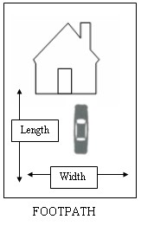

Residential roads 4.3 metres length x 2.4 metres width Main roads 4.8 metres length x 2.4 metres width.

- On a site on a classified road, I can provide turning space of ______ metres x ______ metres within my property.

- My vehicle will not overhang the public footpath when I park within my property.

Signed ………………………………………………….……….… Date………………..…………….

Please send the completed form (both pages) to contractors of your choice (from the approved contractor list) for a quotation to be prepared.
Restricted Streets:

Barnes Road
Barnes Way
Connaught Road
Richmond Lane
Richmond Way
Runnymede Avenue
Runnymede Lane
Shinewater Park

List Of Kingston Upon Hull Classified Roads

A Classification Roads:

Anlaby Road – A1105 (Ferensway to Boothferry Road)
Askew Avenue – A1166
Beverley Road – A1079
Boothferry Road – A1105
Brighton Street – A1166
Clarence Street – A165 (Holderness Road to Great Union Street)
Clough Road – A1165
Cleveland Street – A1165
Clive Sullivan Way – A63 (T)
Castle Street A63 (T)
Ennerdale – A1033 (Sutton Road to Dunswell Roundabout Via Thomas Clarkson Way And
Raich Carter Way)
Ferensway – A1079
Freetown Way – A165
Ganstead Lane – A165
Garrison Road – A63 (T)
George Street – A165 (Freetown Way to North Bridge)
Great Union Street – A1165 (From Clarence Street to Garrison Road)
Hedon Road – A1033 (T)
Hessle Road – A63 (T) (Castle Street to Clive Sullivan Way)
Hessle Road – A1166 (Brighton Street to Askew Avenue)
Holderness Road – A165
Holwell Road – A1033 (South of Sutton Road)
Mount Pleasant – A1033
New Cleveland Street – A1165
North Bridge – A165
Stoneferry Road – A1033 (Holwell Road to Mount Pleasant)
Sutton Road – A1033 (Ennerdale to Holwell Road)
Wiltshire Road A1166 (North Side)
Witham – A165

B Classification Roads:

Anlaby Road – B1231 (Boothferry Road to City Boundary)
Cottingham Road – B1233
Leads Road – B1237
Main Road (Bilton) – B1238
Pickering Road – B1237 (Hessle Road to Boothferry Road)
Robson Way – B1237
Saltshouse Road – B1237

Classified Un-Numbered (Class Iii)

Albert Avenue
Alfred Gelder Street (Lowgate to Drypool Bridge)
Bricknell Avenue
Boulevard (Hessle Road to Goulton Street)
Calvert Lane
Calvert Road
Cavendish Road
Chamberlain Road
Chanterlands Avenue (Bricknell Avenue to Spring Bank West)
Church Street – Sutton
Commercial Road
County Road North
County Road South
Drypool Bridge
English Street
Fairfax Avenue
Goulton Street
Greenwood Avenue (Hall Road to Beverley Road)
Hall Road (Greenwood Avenue to Cottingham Road)
Hedon Road (Great Union Street to Mount Pleasant)
Hessle Road (Brighton Street to Rawling Way)
Hessle Road (Priory Way to Askey Avenue)
Holwell Road (North of Sutton Road)
Ings Road (Cavendish Road to Holderness Road)
Jackson Street
Kingston Street (Commercial Road to English Street)
Laburnum Avenue
Lowgate (Market Place to Alfred Gelder Street)
Marfleet Lane (Maybury Road to Burma Drive)
Marfleet Avenue (West Side – Burma Drive to Hedon Road)
Market Place
Maybury Road
National Avenue (Bricknell Avenue to County Road North)
North Road
Preston Road (Southcoates Lane to Marfleet Lane)
Priory Road
Princes Avenue
Queens Road
Southcoates Lane
Spring Bank
Spring Bank West (Princes Avenue to Calvert Lane Roundabout)
St. Georges Road
Sutton Road (Beverley Road to Ennerdale And Holwell Road To Cavendish Road)
West Dock Street
Walcott Street
Wawne Road
Willerby Road

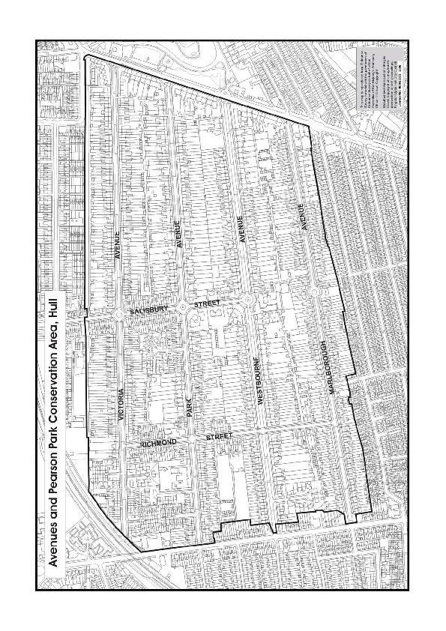
Hymers/Sunny Bank conservation Area.

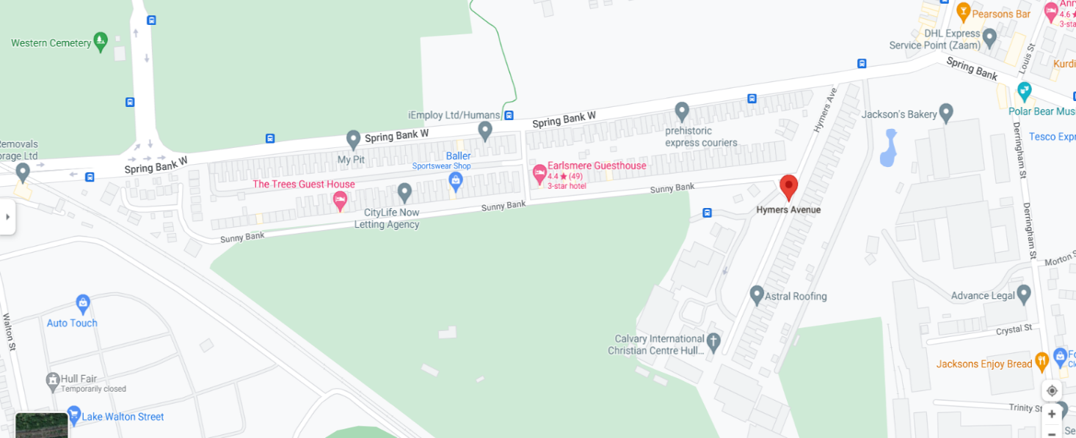

Garden Village conservation area
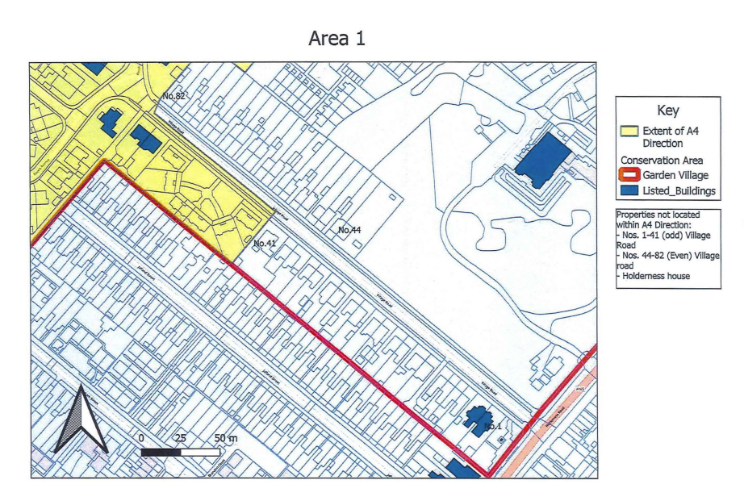

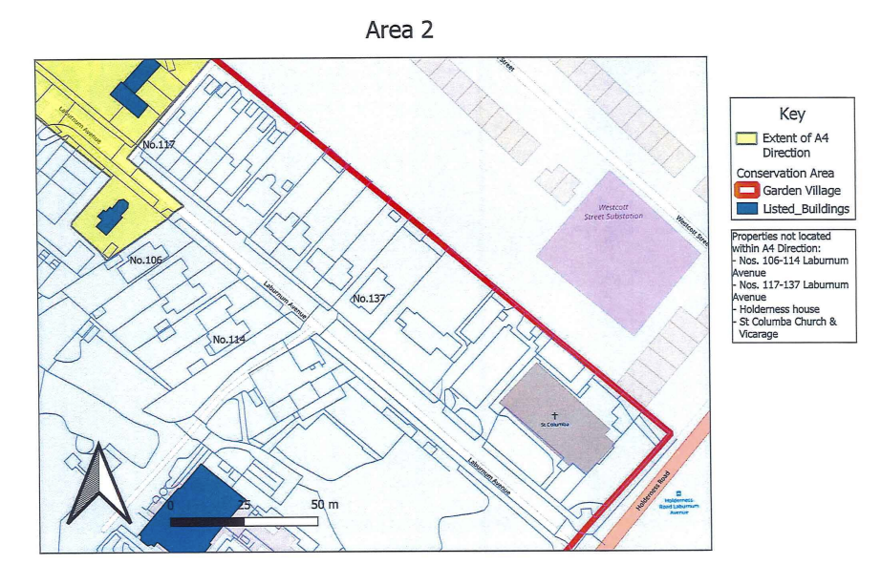

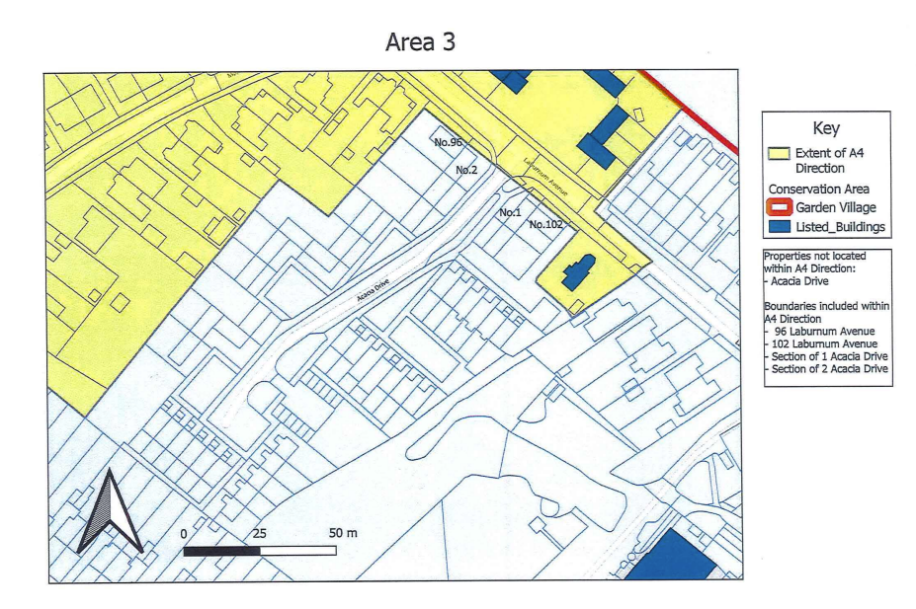

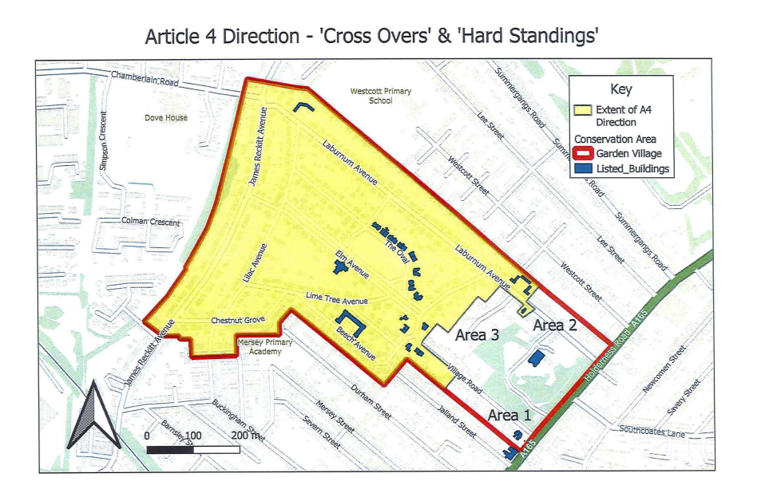

Approved contractors – contact information

Company name | Address |  | Telephone number and contact name
A J Driveways | 35 Farndale Avenue  Hull  HU9 2PH | John Redfern  ajdrivewaysltd@hotmail.com  07412194824
AAA Groundwork’s & Construction Ltd / MMB Landscapes Ltd | 2 Holme Church Lane  Beverly  HU17 0AR | 01482 575041 / 07914853141  Michelle Lazenby  AAAgroundworks@hotmail.com
Abstruct Groundworks & Driveways | 17 Rosedale Avenue  Hull  HU9 2PL | Timpearce87@gmail.com  07834995775 / 01482 708778
Active Works | 553 Holderness Road  Hull  HU8 9AA | Nigel Sisson  Nigel.activeworks@gmail.com  01482 447543/07976979826
All Aspect Groundworks Ltd | 7 Overland Road, Cottingham, HU16 4PY | Steph_aag@outlook.com / Jamie_aagroundworks@outlook.com  07591814452 / 07549899243
AMBA Construction Ltd | 29 Callerton Street Hull  HU3 5BH | 01482 563838 / 07795158156  John Perry  Amba@redd.karoo.co.uk
Ambledon Civils LTD | 41 Hambledon Close  Kingston upon Hull  HU7 6AR | 07852749194  Paul Fowler  ambledoncivils@outlook.com
Anderson Groundworks (Hull)  LTD | Springfield Medow  Garton Road  Aldbrough Hull  HU11 4QA | 07932091336 / 01964 527125  Paul@andersongroundworks.com
BDS Yorkshire | Unit 55  Kelleythorpe Industrial Estate Warfield Road  Driffield  YO25 9FQ | 01377 240403  info@bdsyorkshire.com  www.bdsyorkshire.com
BRC Construction | 21 Hall Leys Park  Kingswood  Hull  HU7 3GN | Matt Brooks  BRC-Construction@outlook.com  07885429547
BSJ Civils Ltd | 207 Gleneagles Park Hull  HU8 9JS | Bsjcivils@aol.com  07709837401
EC Surfacing Ltd | Europa Way, Brigg DN20 8UN | Elise Huxford – elise@ecsurfacing.co.uk  01652 657651
ELS Surfacing and Civils Ltd | Wilberforce Street Hull,Church Road Romford RM3 0JU | Tony Smith – 07455 189099  Ryan Andrews- 07966683555  Keith Richardson-07881093469  Keith.richardson@els-group.com
Humberside Fencing & Landscaping | 1039 Anlaby Road  Hull  HU4 7PW | Lewis Dickinson  Humbersidelandscaping@hotmail.com  Amy - 07566227595
LC Atkin Surfacing | 7 Ellerman Wilson Warehouse, Kingston Street HU1 2EH | Lewis Atkin – 07468455344  Gary Atkin – 07379636613  Email - lcatkinsurfacing@gmail.com
M B Roche & Sons Ltd | 28 The Weir Hessle  HU13 0RU | 01482 648731  Daniel Roche  rochecivilengineering.com
Mod-Gen Construction Ltd | 237 Main Road  Bilton  HU11 4DX | Ryan Sharp – 07984210133 / 01482 680442  info@Mod-Gen.co.uk
Nu-Lawn Landscapes | Welton Hall  Apartment 1  1 Dale Road  Welton HU15 1PE. | 01482 627626 / 07768 652447  Eliott Cattaneo  e.catt31@yahoo.co.uk
Pave-Away | The Builders Yard  73 Station Road  Nafferton  East Yorkshire YO254LS | 01377 252044  Pave-away@tiscali.co.uk
PBS Construction (North East)  Ltd | 1 Trinity Street  Kingston Upon Hull  HU3 1JR | 01482 211132
Redevelop Civil Engineering Ltd | 13 Plantation Dr E, Hull HU4 6XB | info@redevelopcivils.co.uk  Owen Wood  07702 022734  Tim Redgrave - 07977 570015
Resin works Hull & Yorkshire | 80 Sibelius road  Hull Hu4 7NN  07783195734 | 07783195734
S & R Groundworks | Melton Industrial Park  Gibson Lane  Melton  HU14 3HF | 07855 040904  sandrgroundworks@gmail.com  Richard Pinder
Saltmer Construction Ltd | 2 Hull Bridge Road, Beverley,  HU17 9HZ | Johnny Saltmer – saltmerconstruction@gmail.com  Johnny Saltmer – 07534830683
Sanderson Fixing Services Ltd | 147 Sutton Road  Hull  HU6 7DP | Ian Sanderson  07712344766  ian@sfixsltd.co.uk
Total Surfaces | 65 Western Gailes  Way  Hull  HU8 9EQ | 01482 715332 & 07955064101  Danny Green  Info@totalsurfaces.co.uk
Wise Streetworks & Construction Ltd | Melton Court , Gibson Lane South, Melton  HU14 3HH | Paul Railton – paulrailton@wisetrmelton.com  Karina Railton – info@wisetrmelton.com  07736311977/ 01482 638670
Wrights Civil Engineering | Main Street  Hull  HU2 0LA | 01482 218183
Wyke Groundworks | 13 Frankland Drive, Cottingham, East Yorkshire, HU16 5UY | Garry Ireland  07534 991136 - Wayne Magee 07542 339461 sales@wykegroundworks.co.uk

Quality Control Code 000816

